Shabbos Stories for
Parshas vayeishev 5782
Volume 13A, Issue 14 - 23 Kislev/November 27, 2021
Printed L’illuy nishmas Nechama bas R’ Noach, a”h

For a free subscription, please forward your request to keren18@juno.com
Past stories can be found on the website ShabbosStories.com

A Mighty Mother’s Triumph
By Rabbi Kalman Samuels

A defective medication rendered Yossi Samuels blind, deaf, and acutely hyperactive. In 1981, his family merited a rare yechidus (audience) with the Lubavitcher Rebbe, zt”l, arranged by them by the Rebbetzin. In the above photo Yossi and his father meet with then President George Bush in the White House.

Rabbi Kalman Samuels is the co-founder and president of Shalva, the Israel Association for the Care and Inclusion of Persons with Disabilities. He was interviewed in March of 2020.

Our Second Child was Born Perfectly Healthy
Our second child, Yossi, was born a perfectly healthy baby, but all that changed when he was only eleven months old. At that time, in the second half of 1977, the Ministry of Health in Israel had received two faulty batches of the DPT vaccine which normally protects a child against diphtheria, pertussis (also known as whooping cough) and tetanus. And, unfortunately, Yossi was one of the last kids to get this vaccine from the bad batch before the authorities realized there was a problem and stopped using it.
Sadly, he became blind, deaf and very hyperactive. Overnight, our lives had been turned upside-down.
I had been ordained as a rabbi and I thought that the rabbinate would be my future. But now it became apparent that it wouldn’t be.
Because we couldn’t get what we needed in Israel, we came to New York seeking medical intervention. My uncle, Dr. Hershel Samuels, was the co-director of the orthopedics department at Maimonides Medical Center, and he put us in touch with several top neuro-ophthalmologists. From them we learned very quickly that Yossi’s optic nerve was damaged, and he would never see again.
As doctors in the US were being very helpful and forthcoming, we decided to stay on, and I began working in the computer field.

A Visit from Uncle Hershel
Then one day, in the Spring of 1981, while my uncle Hershel was visiting, he happened to mention one of his patients, a Mrs. Schneerson. He rarely spoke about those whom he treated, but he couldn’t say enough good things about her – how eloquent she was, how cultured, how brilliant.
“Are you talking about Mrs. Schneerson, the Lubavitcher Rebbe’s wife?” I asked.
Indeed, that is who he was talking about. So, I said to him: “If you could get me a blessing from the Rebbe for Yossi, it would mean the world to me.”
“No problem,” he responded. “Next time that Mrs. Schneerson comes to see me, I will ask her.”
Six weeks later, he called me. “Mrs. Schneerson came in earlier and I told her that my nephew would like a blessing from her husband for his sick child,” he said. “She promised to arrange it and she just called. You are to come to see the Rebbe at three o’clock tomorrow.”
I got very excited, and I called Rabbi Yitzchok Wineberg, the Rebbe’s emissary in Vancouver, my hometown. When he heard that I had an appointment, he laughed. “Kalman,” he said, “even my father, a senior Chabad emissary, can’t get to see the Rebbe. Your uncle means well, but I seriously doubt you will get to see the Rebbe in person.” (Apparently as a result of his heart attack four years prior, private audiences with the Rebbe were no longer possible.)
However, I was not deterred. The next day, I took time off from work and drove to Chabad Headquarters in Crown Heights together with my wife Malki and Yossi. I left them in the car and ran into the building to see if this appointment was for real. It was! The Rebbetzin had indeed arranged it, and immediately after the brief afternoon prayers, Rabbi Binyomin Klein, the Rebbe’s secretary, took us directly to the Rebbe.

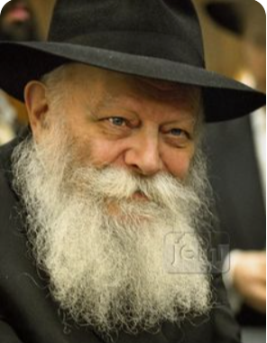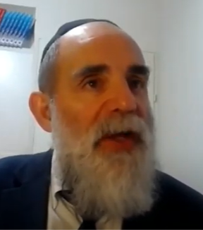
The Lubavitcher Rebbe, zt”l and Rabbi Kalman Samuels

Just before our visit, a famous neurologist had suggested putting Yossi into the hospital for several days to conduct a battery of tests, but Malki was very much against it. “I am not going to have him poked and prodded,” she insisted. “He won’t understand what is being done to him and he will be terrified. In any case, these tests may lead to nothing, as the doctor said. And they might even do him further damage.”
We discussed this with the Rebbe at length, and he advised us to consult two experts. He said if the two experts agree that this is the best course of action, we should do what they recommend. But if they differ, then we should sit down with our uncle and decide together what to do. As it turned out, the experts differed, and we did not put Yossi in the hospital for all those tests.
While we were speaking with the Rebbe, Yossi was running around the office, because we just couldn’t control him. The Rebbe gave him a nickel, he took it, ran around and threw it on the floor. Then the Rebbe gave him another nickel and he did the same thing. This happened several times.

My Wife and I Were Deeply Embarrassed
Meanwhile, my wife and I were dying of embarrassment. Seeing our discomfort, the Rebbe reassured us, “Let the child be – he is demonstrating a healthy quality.”
During the course of the conversation, I mentioned to the Rebbe that Yossi is a direct descendant of King David through his mother. At this point, the Rebbe turned his focus directly to Malki and, while addressing both of us, he looked her in the eye with a piercing gaze for several minutes.
It was astonishing moment. Later I learned that according to chasidic teachings, whenever the Rebbe looks at somebody for a long time, it is to transmit spiritual strength to that person. Subsequently, Malki developed extraordinary strength, and she ended up founding Shalva, which has developed over the years to be one of the largest and most advanced centers for disability care and inclusion in the world.
As for Yossi, the Rebbe also saw in him something others couldn’t see. Well-meaning people told my wife to put Yossi in an institution because it would be impossible for her to raise a family with him in the house. It’s true that we had to watch him constantly. We could not have any glass in the house because he was so full of energy that he was likely to break things and hurt himself. At night, Malki would cry out to G-d, promising that if He would help Yossi, she would dedicate herself to helping others in the same situation.

And G-d Did Help Yossi
And G-d did help Yossi. After we moved back to Israel, he merited to find the right teacher – Shoshana Weinstock – who was deaf and had an amazing amount of patience. She would put one of his palms on the table and then would spell “table” via sign language into his other palm. She did this over and over again, for days on end, until he made the connection that these symbols stood for the object he was touching. When he finally got it, his face lit up and then there was no stopping him.
She went on to teach him the twenty-two letters of the Hebrew alphabet and then built up his vocabulary. As well, a speech therapist taught him to speak Hebrew synthetically. For the first time, at age eight, he was able to communicate. At that point, Malki sat me down and said that now it is time to make good on her promise to G-d. This is how the creation of Shalva was set in motion.
It soon became clear that Yossi was a brilliant child and, as the Rebbe had immediately seen, a child gifted with amazing tenacity.
Even when, at age twenty, he lost his ability to walk, he insisted on traveling. He wanted to ride elephants in Thailand, and he rode elephants in Thailand. It turned out that he had an amazing sense of smell, and he became a sommelier, a wine master. His wines, called “Yossi,” are well received and are sold in the duty-free shops at Ben Gurion Airport.
That day when we met the Rebbe, he never stopped taking the Rebbe’s nickels, and hopefully he will never lose that tenacity to always keep moving forward.

Reprinted from the December 3. 2020 edition of Here’s My Story [with the Lubavitcher Rebbe.] For more information about the amazing Samuels family and the incredible organization they have created – the Shalva National Center that offers disability services and support to families in Israel under the motto – “Inspiring Hope, Changing Lives,” google a recent video interview with co-director Kalman Samuels – “Dreams Never Dreamed – Ahawas Achim B’nai Jacob & David.”
Your Trip Should
Be Successful

This is a time of corona and the Rav’s health is not good. Receiving people is very limited and even if I would come and talk with the Rav, it is not nice and not right to burden the Rav in his condition. I needed advice in several important matters that could not be delayed, and I did not want to be a burden when he is weak…
While I was undecided how I should act, I received a call from the Rav who asked, “On Friday on your way home, could you take me to Beitar? I have a family simcha and I want to be in Beitar.”
I replied, “Gladly and wholeheartedly!!!” Of course, I picked up the Rav at the designated time and we traveled together to Beitar. On the way, the Rav was interested in my situation, and we had enough time to talk calmly without being a burden. This is how Hashem prepared all the answers for me and removed all doubts in the best possible way.
The Rav wanted to know if I lived near where he was staying in Beitar, and I told him I live in Yerushalayim. It was only then that the Rav realized that he had made a mistake and inadvertently called me instead of my brother-in-law who lives in Beitar.
For my part, I calmed the Rav and I told him how important it was for me to speak with him and it was hashgacha in the matter!!! Also, every Shabbos I am busy with preparations until the last minute, but this Shabbos I arranged everything early so that I could start Shabbos calmly in the merit of the trip. Now my excitement was doubled as it became clear that because of the mix up he called me for the trip.
On my way back to Yerushalayim, I got a call from the Rav asking if I would check if he left a small bag in the car. I checked and the bag was in the car. I was already as the entrance to Yerushalayim, and to go back would take a lot of time. But the hand of hashgacha was here as well.
A relative was unexpectedly delayed in Yerushalayim and was just about to leave for Beitar. I made up to meet them on the way, and I gave them the bag to give to the Rav before Shabbos. Any observer sees how everything is prepared and supervised, and when we understand this, we live happy, rich lives.

Reprinted from the Parshas Chayei Sarah email of Tiv Hakehila.

The Sultan’s Valuable Sword

The Meoras Ha’Machpeilah is the final resting place of four couples: Adam/Chavah; Avraham/Sarah; Yitzchak/Rivkah; Yaakov/Leah. As such, it is sacred ground which no one has penetrated and returned to report about. There was, however, one person who went, entered and even, exited – Horav Avraham Azulai, zl, author of the Chesed L’Avraham, great-grandfather of the Chida, zl.
The story took place in 1643, in the city of Chevron. The sultan of the Ottoman Empire [Sultan Ibrahim who ruled from 1640 – 1648] decided to visit the many places of distinction that were part of his vast empire. Chevron, which is home to the Meoras Ha’Machpeilah, was one of his stops. He entered the cave adorned in his royal garb, including his unique golden, diamond studded sword which hung at his side.
He went from room to room, finally entering the huge hall named after Yitzchak Avinu. The centre of attraction in the Yitzchak Hall is a small circular hole in the floor, which is considered to be the most sacred spot in the entire structure, since it leads down into the caves/burial place themselves.
People would come from all over the world just to stand and pray at this hole, which according to tradition was excavated/created by Adam HaRishon. The sultan leaned over the aperture and peered down into the hole. As he bent over, his precious sword became loose and tumbled through the opening. When the sultan heard the clang of metal hit the ground of the cave, he realized that his sword was now in the mysterious burial place of the Patriarchs and Matriarchs.
He wanted his sword retrieved. He ordered the officer of the guard to send down a soldier to bring back the sword. Not one to waste the sultan’s time, the officer immediately dispatched a soldier through the hole, after first tying a strong rope around his body. No sooner had the soldier been lowered when they heard piercing screams coming from the cave below. They pulled up the soldier, who was no longer alive! The sultan kept on sending soldiers down into the hole – with the same result: no sword, and another dead soldier.

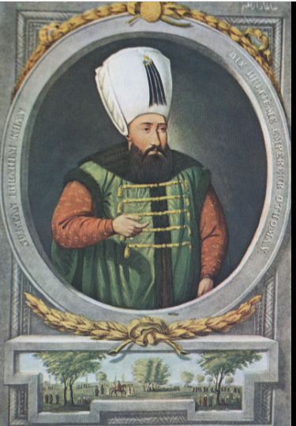
Sultan Ibrahim the Deli (Mad)
The sultan had little concern for his soldiers. He just wanted his sword back. Finally, the officers suggested, “Since there are so many Jews in Chevron let one of them descend into the hole. Why should our soldiers die?”
Word was sent to the Jews that the sultan expected one of them to retrieve his sword. No Jew was prepared to forfeit his life. The sultan “sweetened” the deal when he said, “Unless a Jew descends and retrieves my sword, the entire Jewish community will pay with their lives!”
Sadly, this is the type of tyranny under which we had lived throughout our exile. Not willing to put anyone’s life in danger, the elderly Rav of Chevron, the Kabbalist, Rav Avraham Azulai said that he would go down. “I have no fear,” he said.

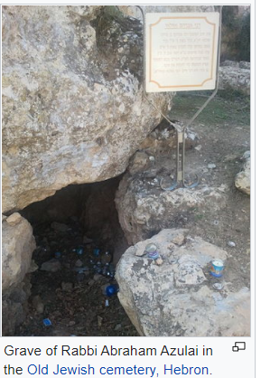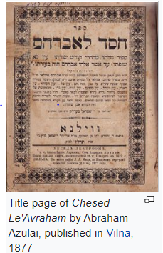
Illustrations from Wikipedia

Rav Azulai prayed passionately for guidance and success, and dressed in his white tachrichim, burial shrouds, he then set forth for the cave. With a rope tied around his waist, the elderly Rav was lowered down to the ground of the cave.
He was met by three bearded men, who “introduced” themselves as the Patriarchs. Rav Avraham was in total shock. “Why should I leave here?” he asked. “I am old. I have come face to face with my Patriarchs. I desire to stay here with you.”
The Patriarchs replied, “You must return the sultan’s sword or the entire Jewish community of Chevron will be annihilated. However, have no fear, for in another seven days you will return here to be with us.” The Rav returned to a hero’s welcome. After returning the sword to the sultan, he quickly went to his shul where he spent the next week transmitting to his students all of the esoteric teachings of the Torah. He learned with them night and day, imparting to them all that he knew. Seven days after entering the cave of Machpeilah, Rav Avraham Azulai was called “Home,” returning his lofty soul to its Heavenly Source. He was buried in the ancient Chevron cemetery, overlooking the final resting place of our Patriarchs.

Reprinted from the Parshas Chayei Sarah 5782 email of Rabbi A.L. Scheinbaum’s Peninim on the Torah.

The Rav Who Tore Toilet Paper on Erev Yom Kippur
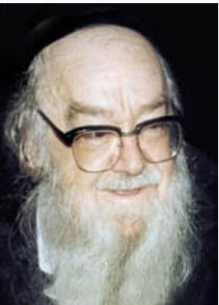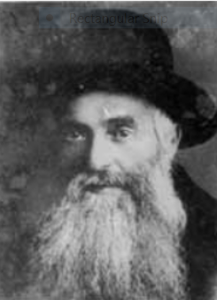
Rabbi Sholom Schwadron Rabbi Eliyahu Dushnitzer

Horav Sholom Schwadron, zl, related the following vignette concerning Rav Dushnitzer when he was the Menahel Ruchani Ethical Supervisor, of Yeshivas Lomza in Petach Tikvah:
A man who was totally secular in his faith and commitment to Judaism walked by the yeshivah on erev Yom Kippur. He noticed that outside of the sheirutim, the room which housed the lavatories, there stood an elderly rav sporting a long, white beard, tearing toilet paper.
Why would a man who appeared to be a distinguished person stand outside the lavatory tearing toilet paper on erev Yom Kippur? The man could not contain his incredulity, so, he approached the Mashgiach and asked what and why he was doing this?
The Mashgiach, in his quiet, humble manner, replied, “Tomorrow is Yom Kippur, and we will be having many guests joining us for the tefillos. As a result, it is expected that this area will be used and paper will be needed. Thus, I am making sure that the necessary paper is available.”
The man who related this incident to Rav Sholom said, “With each rip of the paper, he was ripping my heart! To see such an eminent person care for others on a day when he surely had much more to do for himself, inspired me to begin reflecting on my life and how I had wasted it.
Immediately after Yom Kippur, I made an appointment to meet with the mashgiach and asked him to help me while I could still save myself and my future generations.” All this happened because a holy man cared about the “little things” that people needed.

Reprinted from the Parshas Chayei Sarah 5782 email of Rabbi A.L. Scheinbaum’s Peninim on the Torah.

The Chocolate Cake

If we notice how resourceful and ingenious, we can be at justifying behavior, how clever and capable we are at excusing ourselves and those we love, then we must acknowledge that if it’s difficult to judge others favorably, it is not because we are lacking the talent or skill. We are only lacking the will.
One of my nieces, of whom I am especially fond, had finally found the time in her busy social schedule to accept my Shabbos invitation. She came Friday afternoon and decided she wanted to bake me a cake. I was busy around the house, and when I came into the kitchen, I found it a complete mess.
What surprised me the most was my own reaction. I didn’t mind. I just picked up everything, cleaned up, and that was it. If anybody else would have done it, I probably would have hit the roof.
Shabbos afternoon, when I went to the freezer to give myself the treat I had saved – the last of the chocolate ice cream – it wasn’t there! All I could think was, I’m glad she enjoyed it and felt at home.
It is an important insight for us. WE TEND TO JUDGE PEOPLE, NOT ACTIONS. It really depends on WHO says it and WHO did it, and not WHAT was done. (The Other Side of the Story by Yehudis Samet)

Reprinted from the Parshas Lech Lecha 5782 email of The Weekly Vort.
Shabbos is Shabbos!

Rebbetzin Ruchama Shain recalled the following story in ‘All for the Boss’. It was on August 16, 1939, that Papa and Mama began their voyage to Eretz Yisroel. They were scheduled to dock at the port in Haifa on Wednesday, August 30. Arrangements were made for Papa and Mama to stay in Haifa for a few days at the home of Rabbi and Mrs. Alfa.

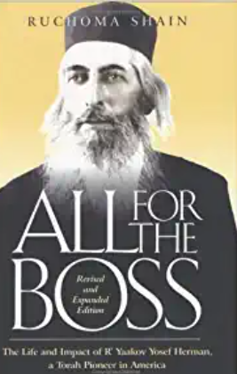
In mid-route, the captain received orders to sail in a circuitous route in case the waters of the Mediterranean Sea had been mined because of the impending war. And so, instead of arriving on Wednesday as scheduled, the boat docked on Friday, September 7, one hour before sunset. A few hours before that, World War II had erupted with the German invasion of Poland.

Instructions from the Loudspeakers
From the loudspeakers came the announcement that passengers were to disembark immediately. All the baggage from the hold of the ship would be unloaded onto the pier, and the passengers would be responsible for having it removed as quickly as possible.
Pandemonium reigned. Papa and Mama were terribly upset. It would soon be Shabbos! How could they take care of their baggage when they would have to leave the port immediately in order to get to Rabbi Alfa’s house in time for Shabbos? Papa grabbed the suitcase that contained his Sefer Torah and his Tallis and Tefilin, and Mama took only her pocketbook. They edged their way through the pier and asked to be shown to the head customs officer.

The Tall English Officer
A tall English officer listened as Papa explained to him, “I cannot deal with our baggage now. I have never desecrated the Sabbath in my life. To arrive in the Holy Land and desecrate it here is impossible!”
Tears rolled down Papa’s cheeks. The officer answered curtly, “Rabbi, this is war you must make allowances.” “Just stamp our passports and let us through. We’ll pick up our baggage after the Sabbath,” Papa pleaded.
“That will not be possible. We are removing all the baggage from the ship and leaving it on the pier.”

Please Stamp our Passports So We
Can Leave in Time for Shabbos
“I don’t care about our baggage! Please, just stamp our passports so we can leave.”
The officer looked at Papa quizzically and said, “How much baggage do you have?”
“Sixteen crates in the hold and nine suitcases in our cabin.”
“What?! Do you realize that once you leave here, your baggage will be on the pier with no one responsible for it? By tomorrow night, I assure you, you will not find a shred of your belongings. The Arabs will have stolen them all!” the officer said emphatically.

“I Have No Alternative”
“I have no alternative. It’s almost time for the Sabbath, and we cannot travel on the Sabbath. Please, please, just clear our passports and let us go,”
Papa’s voice rose in desperation. The officer, incredulous, called to another English officer, “Stamp their passports and let them through. This Rabbi is willing to lose all his belongings in order to get to where he’s going in time for their Sabbath.”
The second officer stared at Papa in amazement, as he stamped their passports and cleared their papers. Papa, clutching the suitcase with his Sefer Torah, and Mama, holding on to her pocketbook, grabbed a taxi and arrived at Rabbi Alfa’s house just in time for Mama to light the Shabbos candles.

Papa was Spiritually Elated
That entire Shabbos, Papa was spiritually elated. Over and over again he repeated to Mama, “The Boss does everything for me! What could I ever do for Him? Now at last I have the Zechus to give up everything we have for the Boss for His Mitzvah of Shabbos, and to make a Kiddush Hashem!”
For Mama it was difficult to share his elation fully. She was physically exhausted and emotionally grief-stricken. The loneliness for her children weighed heavily on her mind and heart. The additional loss of all her worldly possessions was not an easy pill to swallow. But Mama did not complain.

A Suggestion to Go to the Port
On Motza’ei Shabbos, after Papa had waited the seventy-two minutes after sunset to Daven Maariv and then make Havdalah, Rabbi Alfa suggested to him, “Let’s go to the port. Maybe some of your crates are still there.”
Papa and Mama did not share his optimism, but they went along with him. It was pitch dark at the port. However, they spied a little light at the far end of the pier.
As they neared the lighted area, a voice with an English accent rang out, “Who goes there?” Papa called out, “Some passengers from the boat that docked late yesterday afternoon.” The English guard approached them. “What is your name?” “Jacob J. Herman,” Papa answered.

It’s About Time You Came
“Well, well, Rabbi, it’s about time you put in your appearance. I was assured that you would be here the minute the sun set. You are a little late. I have been responsible for your baggage for more than twenty-four hours. My commanding officer said he would have my head if any of your baggage was missing. Kindly check to see that all is in order and sign these papers. Please remove it all as quickly as possible, because I am exhausted!”

Reprinted from the Parshas Lech Lecha 5782 email of Rabbi Yehuda Winzelberg’s Torah U’Tefilah

A 20th Century
Legacy of Chevron

In the city of Chevron, in 1929, the Arabs rioted and killed 67 Jews, including 24 talmidim (students) of Yeshivas Chevron. Neither those Arabs who had previously appeared friendly, nor the British police, did anything to stop the deadly mob. Rabbi Meir Chodesh, Z"TL, the great Mashgiach of Yeshivas Chevron, survived the terrible massacre. Although he went on to lead the rebirth of the yeshiva in Yerushalayim, he nevertheless carried within him the full weight of that horrific day.
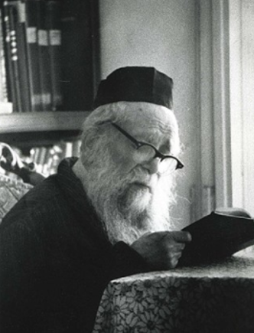
Rabbi Meir Chodesh

His daughter, Rebbetzin Shulamit Ezrachi, wrote: “Many years later, in discussions with his students, when the atmosphere was right, the Mashgiach would describe those moments. He would claim that one must be careful not to let the great moments of one’s life - even the more harrowing ones - become lost in the mists of time. They remain in a person’s inner soul, and one must take care to take them out at critical junctures.”
Comment: Rashi (source) states that all 127 years of Sarah Imeinu’s life were “shavin litova”, all were equally good. Doesn't that sound astounding? Sarah was childless for 90 years! She, together with Avraham Avinu, lived through numerous trials and tribulations. She suffered through mistreatment at the hands of Pharaoh and Avimelech. How can her entire lifetime be regarded as all good years?
Rabbi Nochum Perlow, the Novominsker Rebbe, Z"TL, answers that for most people, time dictates their lives. However, a person who understands their purpose in life, and has a specific mindset and unwavering goal at all times, has a big advantage: he or she dictates time. Sarah Imeinu knew all too well the ups and downs of life. Yet, she utilized every occasion as an opportunity to serve Hashem, and to be Mikadesh Shem Shamayim (sanctify the Name of Heaven) at all times!

Reprinted from the Parshas Lech Lecha 5782 email of Reb Mendel Berlin’s Torah Sweets Weekly.

